Automated Gateway scripts won't run in the new environments because the page names have different numbers associated with them.

The QA Sunpass environment url is:
https://qa.sunpass.com/index

QA2 SunPass Gateway environment url is:
https://qa2.sunpass.com:18181/index

- I tried to run an existing GATEWAY script against the new environment by simply changing the url.
- The result was an immediate failure because the page names are different.
For example the welcome page in regular QA regular environment is:
pageWelcomeFloridaVisitors

The welcome page in the new QA2 GATEWAY environment is:
pageWelcomeFloridaVisitors3

- The number 3 at the end makes the entire page different, so TestComplete is not recognizing it. This concept is for every page in each environment.

Below are examples of a simple login example where I’m clicking on the Replenish account link.

Example 1: QA SunPass:
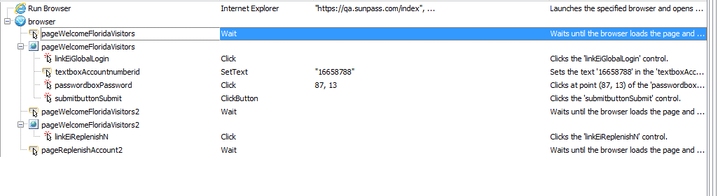
QA2 SunPass CC GATEWAY environment:
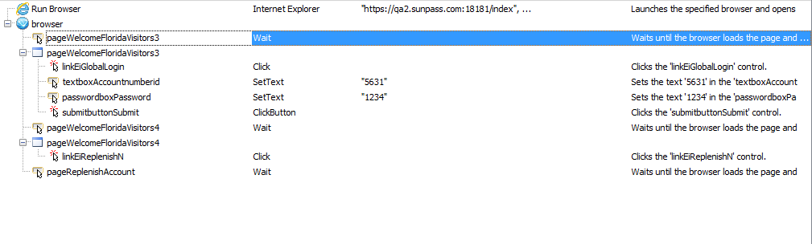

Same goes for the TBP QA environments:
Example 2: QA TBP:
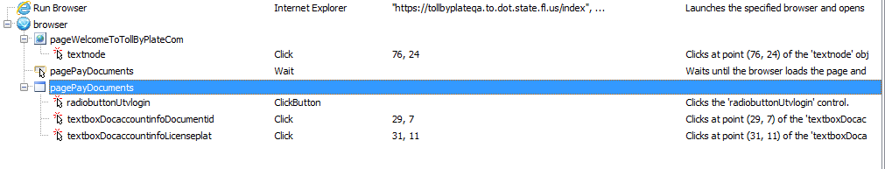
QA2 TBP CC GATEWAY environment:
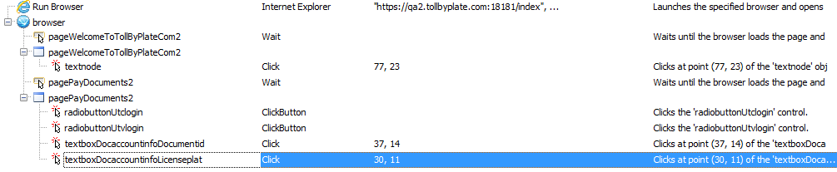

When I add a wildcard to the landing page via the Name Mapping, I get the msg below.

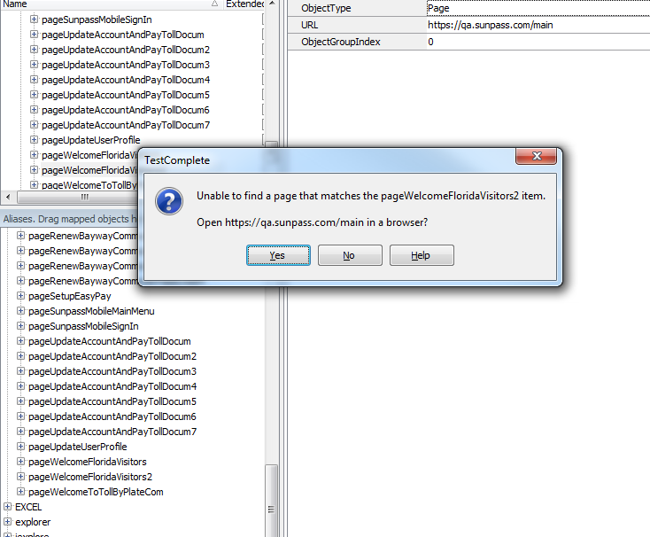

Then I select yes and add the wildcard in the form of an * (also tried ?*) to the welcome page/landing page, but it’s still not working. What else can I try. These scripts must work in other environment or we will NOT use this tool.

